|  |  |  |  |
| --- | --- | --- | --- |
| **Laboratory Report** | | | |
| **Laboratory Exercise No.:** | 5 | **Date Performed:** | March 14, 2023 |
| **Laboratory Exercise Title:** | Analog to Digital Converter | | |
| **Name of Students:** | Danica Marie A. Dumalagan  with: Jhury Kevin P. Lastre &  Paul John R. Toral | **Group:** | 4 |

**Laboratory Exercise #5-1:**

|  |  |  |
| --- | --- | --- |
| **Figure #** | **Input Voltage (V)** | **Output Voltage (V in bars)** |
| 1 | 4.999e-005 | 0 |
| 2 | 0.899 | 1 |
| 3 | 0.999 | 1 |
| 4 | 1.399 | 1 |
| 5 | 1.999 | 2 |
| 6 | 2.549 | 3 |
| 7 | 2.999 | 3 |
| 8 | 3.849 | 4 |
| 9 | 3.999 | 4 |
| 10 | 4.149 | 4 |
| 11 | 4.999 | 5 |

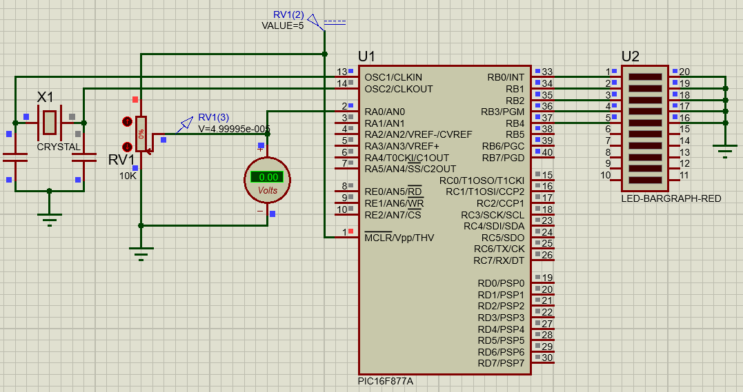

Figure 1.

Figure 2.

Figure 3.

Figure 4.

Figure 5.

Figure 6.

Figure 7.

Figure 8.

Figure 9.

Figure 10.

Figure 11.

**Laboratory Exercise #5-2:**

|  |  |  |
| --- | --- | --- |
| **Figure #** | **Input Voltage (V)** | **Output Voltage (V)** |
| 12 | 0.050 | 0.0 |
| 13 | 0.449 | 0.4 |
| 14 | 0.999 | 1.0 |
| 15 | 1.649 | 1.6 |
| 16 | 1.999 | 2.0 |
| 17 | 2.199 | 2.2 |
| 18 | 2.999 | 3.0 |
| 19 | 3.649 | 2.6 |
| 20 | 4.049 | 4.0 |
| 21 | 4.439 | 4.3 |
| 22 | 4.999 | 5.0 |

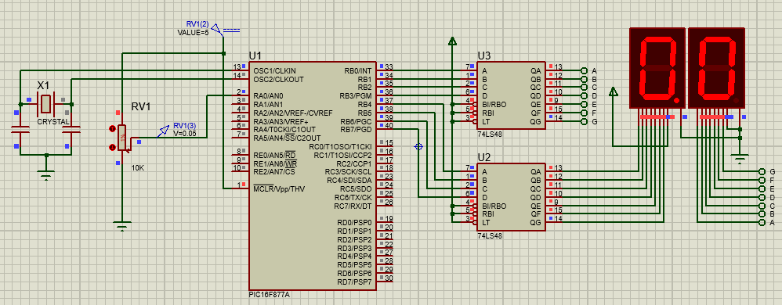

Figure 12.

Figure 13.

Figure 14.

Figure 15. Diagram, schematic

Description automatically generated

Figure 16.

Figure 17.

Figure 18.

Figure 19.

Figure 20.

Figure 21.

Figure 22.